WINDMILLS POWER GENERATION ON BROKEN FRONT LANDS
Understanding Your Property on Coastal Buffs - Slope Stability and Drainage

SOIL DEPOSIT MAKE-UP:

http://www.ecy.wa.gov/programs/sea/pubs/95-107/under01.html

The glaciers deposited the soil layers that make up your slope. The layers consist of glacial till, sand and gravel, and silt/clay. Your shoreline bank or bluff could be composed of one or more of these soil layers. Glacial till is frequently referred to as hardpan because it is very dense, making it difficult to dig. Hardpan is a mixture of clay, silt, sand, and gravel. Water infiltrates through this soil very slowly and consequently water will often accumulate or "perch" above the glacial till during and after wet weather periods.

Sand and gravel soils usually contribute to the stability of a slope in the absence of water. However, water readily flows through sand and gravel. Water can reduce the stability of the slope when it accumulates above a soil layer that is not as permeable as the sand and gravel. Water that accumulates above the impermeable soil layer, can flow laterally until it "daylights" as seepage on the slope face. The impermeable soil layer can be a silt layer within the sand and gravel unit or a silt/clay layer located under the sand and gravel deposits. The impermeable silt/clay layer was compacted under the weight of the overlying soil units and more importantly, the weight of the glaciers. Today's shoreline is a result of continuing geologic evolution since the time of the glaciers. At the top of the slope is a weathered zone (including topsoil) that is usually a few feet thick. Landslide debris and deposits from erosion and weathering can be found on the slope face and at the toe (bottom) of the slope. The debris and deposits usually consist of a jumbled mixture of all the geologic soil layers that make up the slope as well as vegetation that moved down the slope.

SURFACE AND GROUNDWATER:

If significant water is added to the slope such as the sudden increases in ground-water seepage on the slope may reduce the stability of the slope to the point where a landslide occurs. Surface water and groundwater are the two sources of water that contribute to your coastal slope drainage and can accelerate erosion and slope stability problems.

Surface water features can include puddles that form during rainfall. This water usually infiltrates into the soil and becomes groundwater. Other more permanent features include ponds and wetlands that also contribute to groundwater by infiltration.

Groundwater location and movement is generally related to the geology and soils comprising your slope. Groundwater can be located within several feet of the ground surface or deeper in the slope at a sand/clay boundary or in cracks and seams in hard soils or bedrock.

Groundwater often causes slope stability problems when it is present in a sand and gravel layer and is perched (pent-up energy) on top of a silt/ clay layer. The water acts as a soil lubricant which reduces the friction between the sand and silt/clay layers causing the sand to slide on top of the clay. In addition, as the groundwater daylights and exits the slope as seepage, it may erode the sand causing the soil above the sand to become unsupported and fail. Sometimes both the erosional and lubricating effects of groundwater are responsible for large landslides. *1

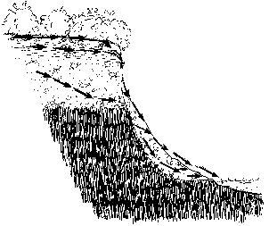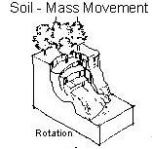

GULLY TO LAKE EROSION

- page 64 - http://www.geologyontario.mndmf.gov.on.ca/mndmfiles/pub/data/imaging/R298/R298.pdf
Large theater-shaped gullies with groundwater seepage and piping of the silt and very fine sand components of the rhythmites contribute greatly to erosion and allow rapid formation (over a period of a few days to weeks) of these theater-shaped gullies. Gully bases are commonly located along the contact between the silt rhythmites and underlying clay rhythmite facies, particularly if this contact is within a few metres of the base of the bluff. Clay rhythmite units are commonly highly deformed and occur higher in section than expected based on an examination of the lateral positions of these units. It is believed that the theater-shaped gullies are the result of a “one time” rapid release of stored groundwater.

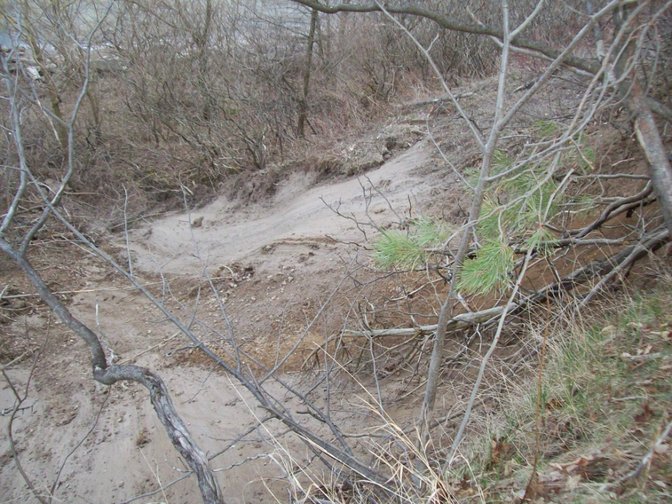

EXAMPLE OF LANDSLIDE DUE TO BULGING AT BLUFF TOE IN PORT RYERSE
NOTE: THIS LOCATION IS PROTECTED BY A 5’ HIGH X 20’ DEEP - CEMENT RUBBLE SHORELINE PROTECTION

A proposed mechanism to store the groundwater near the face of the bluff and to allow it to drain rapidly includes an initial stage of deep-seated plastic deformation of the clay rhythmite unit, causing bulging at the toe of the bluff. The bulging could form a natural dam along the base of the bluff to hold back or retain groundwater within the lower part of the silt and sand rhythmites, until the dam was breached, and the stored water allowed to drain.

The deep-seated bulging and deformation of the bluff may explain the deformed nature and position (i.e., higher in the bluff than expected) of the clay rhythmites in the area of the theater-shaped gullies. Displaced modern shoreline deposits (up to 3m above lake level) are found on the top of crescent-shaped ridges of deformed clay rhythmites. The layers of the clay rhythmites generally dip toward the bluff and lend support to the suggestion of an initial stage of deep-seated plastic deformation.

Human activities along the shore bluffs can alter many of the natural processes and the factors that control the stability of the bluffs. For example, several gullies along the bluffs, head at the ends of drainage tile lines where the flow of water is concentrated. Care must be taken in shoreline management operations and consideration taken of the repercussion to neighbouring land.

STUDY: PORT RYERSE WEST TO PORT BURWELL GEOLOGY

http://www.geologyontario.mndmf.gov.on.ca/mndmfiles/pub/data/imaging/R298/R298.pdf

- page 15
Boyd (1981) has reviewed the literature dealing with the erosion and accretion of Canadian Great Lakes’ shorelines. He established 162 erosion measurement stations, 10 of which were located within the study area. At each of these sites, profiles of the bluff and near shore areas were measured, materials exposed along the bluff described, and samples of each unit were taken between 1973 and 1980. His report summarizes this information and discusses the effects of geomorphological elements on shoreline erosion and processes. The Coastal Zone Atlas demonstrates on air photos the erosion and accretion that has occurred within the Great Lakes area (Environment Canada–Ontario Ministry of Natural Resources 1975).

- page 24
The remaining 2 moraines, oriented nearly perpendicular to the local trend of the Lake Erie shoreline, are composed of Wentworth Till and associated sediments. These are the continuation of the Paris and Galt moraines, 2 strongly developed moraines north of the report area. The younger Moffat moraines (Karrow 1963) may be exposed near Port Ryerse in the Lake Erie shore bluffs, where it is irregular and hummocky.

GALT MORAINE: - page 25
The Galt moraine (Taylor 1913) is a prominent ridge north of Simcoe. Taylor (1913) states that the Galt moraine “is still a distinct ridge at Port Ryerse, where it is cut off by the lakeshore”. A distinct ridge was not observed by the author at Port Ryerse; however, the buried surface of the Wentworth Till is hummocky east of there (Barnett 1978). Barnett (1978) suggested that this moraine may be an extension of the Moffat moraines (Karrow 1963) rather than the Galt moraine. South of the Simcoe area, there is no positive relief associated with the Galt moraine. It is buried for the most part below the lake plain. A series of outcroppings of Wentworth Till southwest from the Town of Simcoe, through St. Williams and Clear Creek, ending at the Lake Erie bluffs in The Sand Hills area, probably delineate this moraine.

- page 30
The portion of the Lake Erie bluffs located between Erie View and Turkey Point is protected from erosion by Long Point and Turkey Point spits and, as a result, is vegetated and relatively stable. Exposures of the sediments composing the bluffs are relatively few; however, the general stratigraphy appears to be: Wentworth Till (clayey silt diamicton) at the base, overlain by rhythmically bedded sands immediately west of Turkey Point, which in turn are overlain by silt and clay rhythmites capped by stratified sands. The sand rhythmites appear to pinch out toward the west.

The sediments making up the Lake Erie shore bluff east of Turkey Point are well exposed. Figure 11 summarizes the general stratigraphic relationships present. The Wentworth Till rises above water level at only a few localities along the lower part of the bluff. It is coarser textured here than where it is exposed farther to the west. The irregular upper surface of the Wentworth Till in the vicinity of Port Ryerse may be the expression of the Moffat moraines as they enter the Lake Erie basin (Barnett 1978). Rhythmically bedded sands and silts are present in the lower part of the bluffs. They thicken and become coarser textured to the southwest, where they become the dominant component of the shore bluff just east of Turkey Point. Several discontinuous, thinly bedded, sandy-textured diamicton layers and lenses, interpreted as Wentworth Till, occur within the sand and silt rhythmites (see Figure 11). At the southwestern end of the bluff segment, faintly stratified silts and clays overlie the sands and silts. These are in turn overlain by a coarsening-upward sequence of silts and sands. At the northeastern end, a thick sequence of silt and clay rhythmites overlies the sand and silt rhythmites.

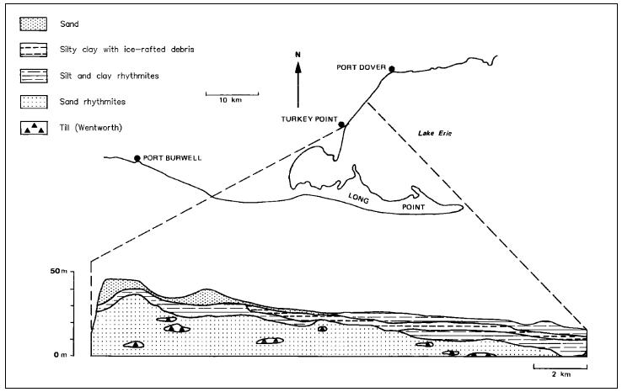
Figure 11. General stratigraphy of the Lake Erie shore bluffs between Turkey Point and Port Ryerse.

SEDIMENTS OF THE GALT MORAINE - page 50
The Galt moraine can be traced from north of Orangeville southward to the Lake Erie shore near Jacksonburg, a distance of some 160 km. It is composed of Wentworth Till and associated stratified sediments which interfinger with radiocarbon-dated, organic-bearing sediments of the Jacksonburg delta (13 360 440 years BP, BGS-929). During the formation of the Galt moraine, water levels in the Lake Erie basin were dropping from Arkona levels to that of the Jacksonburg delta. Water depth at The Sand Hills Park site would not have exceeded 60 m and could have been as low as 1 or 2 m during the formation of this moraine. The source of sediment inflow could have been up to 30 km north of The Sand Hills Park site, but it was most likely nearer.

SEDIMENTS OF THE SIMCOE DELTA - page 52
A large body of stratified sediments overlies the Wentworth Till and is well exposed in the Lake Erie shore bluffs east of Turkey Point (see Figure 11). This body of stratified sediments consists of 2main units: a thick sequence of silt and sand rhythmites overlain by a thick unit of silt and clay rhythmites. The sequence of silt and sand rhythmites is similar to those described as facies associations 2 and 3 of the Jacksonburg delta. The sand and silt rhythmites are thickest in the vicinity of Turkey Point (Photo 8). They are replaced laterally and vertically by the silt and clay rhythmites in the Lake Erie bluff sections but are overlain by gravelly-sand foreset beds and trough cross-bedded gravelly sands further inland along Fishers Creek. Several lenses of sandy textured diamicton occur within the sand and silt rhythmite facies. These diamictons are interpreted as debris flows of Wentworth Till and have characteristics similar to the Wentworth Till exposed elsewhere in this area (Appendixes 3, 4 and 5). The silt and clay rhythmites are very similar to those described as Facies Association 1 of the Jacksonburg delta.

- page 54
The silt and clay rhythmite unit forms high-angle to near vertical slopes making them difficult to study in detail. However, at the Norfolk Conservation Park, 3.5 km northeast of Fishers Creek, this unit is well exposed and accessible. Unfortunately, recent and open contemporaneous slumping of the silt and clay rhythmites makes studies, such as varve counting, difficult.
Gravelly-sand foreset beds overlain by trough cross-bedded gravelly sands underlie rhythmically bedded silts and clays north of the lakeshore along Fishers Creek and an unnamed creek to the northeast. Coarse-grained deposits are believed to be a part of the topset beds of the Simcoe delta (Barnett 1978, 1979). The Simcoe delta was first recognized by Taylor (1913). An attempt to outline the distribution of the coarser facies of this feature was presented in the report on the Quaternary geology of the Simcoe area (Barnett 1978, Figure 12, p.50). Based on the exposures along Fishers Creek, an extension in the distribution of the coarser facies of the Simcoe delta to the southwest is indicated. The rhythmically bedded silts and sands and the silt and clay rhythmites are thought to be the lower delta-front.

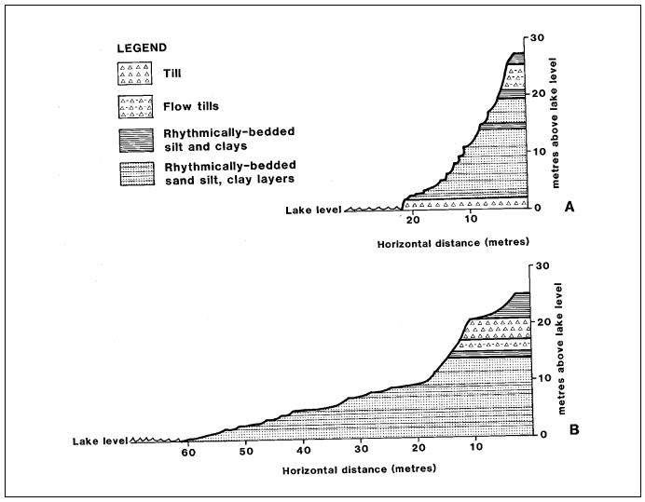
EXAMPLES: BLUFF PROFILES OF LONGPOINT COUNTRY

NORFOLK (NANTICOKE) AGGREGATES – WENTWORTH TILL

GEOLOGICAL TYPES:
Boulder more than 200 mm
Cobbles 75-200 mm
Coarse Gravel26.5-75 mm
Fine Gravel4.75-26.5 mm
Coarse Sand 2-4.75 mm
Medium Sand 0.425-2 mm
Fine Sand 0.075-0.425 mm
Silt, Clay less than 0.075 mm

TILL:
Unsorted and unstratified rock debris, deposited directly by glaciers, and ranging in size from clay to large boulders.

http://www.geologyontario.mndmf.gov.on.ca/mndmfiles/pub/data/imaging/ARIP059/ARIP059.pdf

NORFOLK TILL MAP
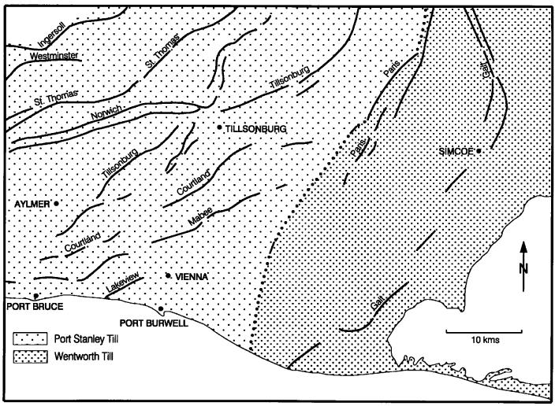

OLDER ALLUVIUM
Alluvium is sediment which is deposited by rivers. Deposition occurs primarily by lateral growth of point bars within the river’s channel or by vertical accretion on the river’s flood plain. Older alluvium is alluvium deposited and preserved on abandoned fluvial terraces. The terraces are underlain primarily by fine-to coarse-grained sand with usually less than 10% gravel content. The terraces probably grade to high pro-glacial lake levels that once existed in the Lake Erie basin. Identification of the particular lake to which each terrace grades is difficult. However, the fanning out of the lower 2 terrace sets at the projected levels of glacial lakes. In the past, gravel and gravelly sand has been extracted along the 3 creeks located north of Turkey Point in Simcoe delta deposits.
AGGREGATE MAP OF WOODHOUSE
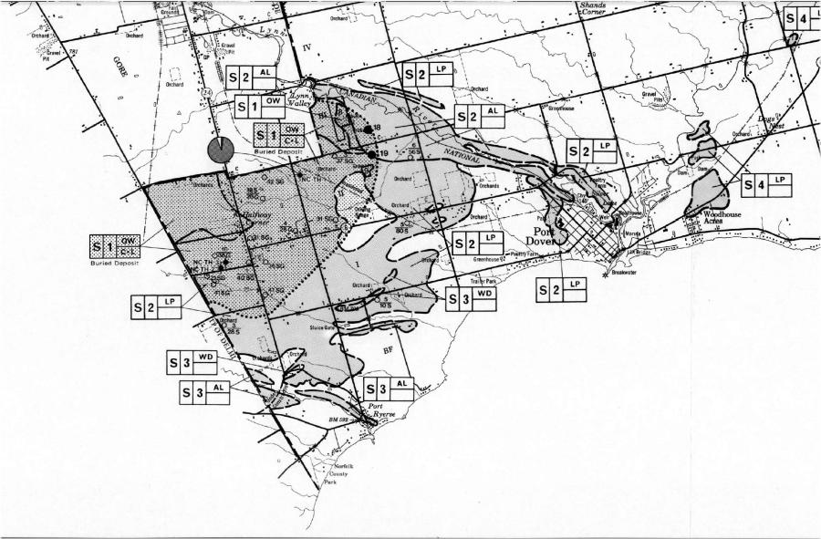

NOTE: TEST HOLE AT PORT RYERSE: (S3|AL) - [S – LESS THAN 35% GRAVEL | 3 – 5-10’ (1.5 – 3M) | AL – OLDER ALLUVIUM]

LANDSLIDE DOCUMENTATION BETWEEN PORT DOVER AND FISHERS GLEN

PORT RYERSE - 1900 - GEORGE J RYERSE

Some Physical Changes:
In going through the Port now to the Lake Shore, no one would realize that in the fifties, directly cross the street, opposite the blacksmith shop of Robert Stalker, there was quite a strip of land between the wagon track and the running stream on which was a good sized barn and a strip eight or ten feet wide between the barn and the creek. The water was then two feet or more higher than it is now. Directly back of the first cottage from the harbor, within my memory, the bank extended forty feet farther south than at present, while west of the row of cottages, two or three hundred feet of the bank of Lot No. 2 has gone into the lake.

LANDSLIDE WEST OF PORT RYERSE CIRCA 1920’S
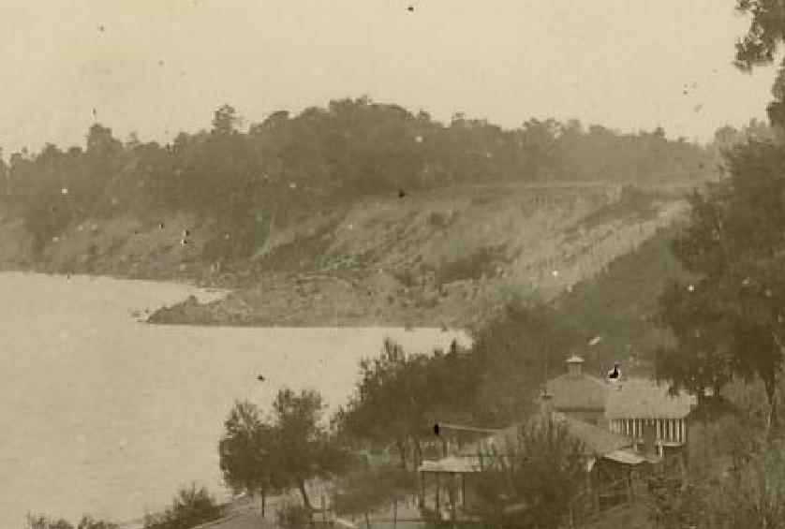

NATURELORE - April 18th, 1985 - - Harry B Barrett

Lake Levels Cause Concern:
With the coming of April it is the hope of the Long Point Bird Observatory that your scribe will rise, for the fifth season, at the crack of dawn to peer seaward [lakeward] from his vantage point at the end of the Blueline road for migrating loons.

Something seemed out of place as I parked the car. As Pappy raced ahead of me he suddenly stopped short on the brink of a bank that was at least thirty feet closer than it had been the morning before, when the wind from the southwest was creating an angry sea at the base of the bank and all along the shore. I had noticed tell-tale cracks across the path recently, as well. As I caught up to Pappy it was obvious that a huge mass of the clay bank, thirty feet in width, over two hundred feet in length, and one hundred feet deep, had broken away and now lay prostrate on the beach and well into the lake. My old observation point, now lays some eighty feet below my feet while many alders lay prostrate around it.

SOMETIME DURING OR, AFTER 1961... RECOLLECTIONS - DOUG GUNDRY - PORT RYERSE

Approximately 3 acres or more was lost due to an instantaneous and massive landslide at Norfolk County Park across the entire face of the park (just West of landslide shown in image above) that let go. It was estimated to have slid a least 100 yards out into the lake, mounding up to 20-40 feet (7-13 metres). This debris took several years to wash away to be unseen. This landslide was also felt by residents in Port Ryerse.

*1 EXAMPLE: When as a child you have had the pleasure to play in a clay-pit on Broken Front land, and upon the arrival to these clay-pits on these lands, they appear dry and solid; With a little foot-work the clay begins to undulate, with water rising to the surface, allowing the clay to become soft and malleable which is great fun on a hot summers day, yet unstable for properties and homes perched atop of this water/clay combination, while enormous windmills constantly vibrate to bedrock immediately behind.

CONCLUSION:
With the erosion knowledge paragraphed above, and collectively, over 100 years of witness to these Broken Front lands, along with the landslide history between Port Dover and Fishers Glen, coupled with the unknown addition of wind mill vibration to these Broken Front lands with their current conditions that exist as described above. We feel as Broken Front landowners, the risks are far too great to install windmills so close to these Broken Front properties.

QUESTION: WITH THE KNOWLEDGE THAT A LAYPERSON CAN WITNESS, RESEARCH AND OBTAIN UPON THE EROSION CHARACTERISTICS OF BROKEN FRONT LANDS; WILL UDI, BORALEX AND ALL OTHER LOCAL PARTNERS AND/OR OTHER INDUSTRIES ATTACHED TO, OR INCREASED BY, THE PORT RYERSE WIND POWER PROJECT, OTHERWISE GUARANTEE THAT NO NEGATIVE EFFECTS (AS LAID-OUT IN THIS DOCUMENT AND/OR IN OTHER DOCUMENTED REPORTS) FROM THIS INDUSTRIAL WIND POWER PROPOSAL WILL OCCUR, AND IF NEGATIVE EFFECTS DO IN FACT OCCUR, THAT ALL PROPERTY OWNERS AFFECTED WILL BE 100% COMPENSATED?

