To whom it may concern:

This is my last letter to summarize all the reasons NOT to industrialize our villages, our wetlands, woodlands, our beautiful landscapes and waterscapes which are:

- We are an attraction to tourists who come to this area from Port Dover down to Long Point, an UNESCO World Biosphere Reserve, all part of our inner bay and one of the most beautiful and historic areas of Upper Canada that remains unblemished to date (except for the horrible mess created to the east of Port Dover with all the ugliness of wind turbines already added there and blemishing the vista looking east).

- It has the largest number of human noise receptors of ANY Wind project, approx. 400 humans surrounding the four proposed.

- Port Ryerse has Blandings turtles and new species we find all the time in the immediate area and the MNR have NOT done a comprehensive study on the private land that the rest of the humans in the area cannot study as it is private land.

- Port Ryerse has 2 species at risk bats and 3 of the proponent farms have barns that they nest in.

- Avalon Rd is the ONLY entrance/exit to 30 homes and the use of this road either during rebuilding of it or during construction of the turbines endangers the lives and homes of the people living there as there is no infrastructure locally to put out fires and even the water has to be trucked in.

- The proposed turning lane construction at the intersection of Wooley and Port Ryerse Rd. HAS NOT had the required species at risk studies done that are required by a FIT contract and HAS NOT had the required archeology studies done that are required by a FIT contract. This area is also a permanent wet land directly attached to the Hay Creek conservation area and should not be disturbed.

- Avalon Rd is the ONLY entrance/exit to 30 homes and the proposed rebuilding of this road endangers the wildlife that uses this road as access to its winter cover in the trees near the lake. This includes but is not exclusive to deer, fox, coyote, and raccoons. This area is in the Long point Bay biosphere catch basin species are varied and tend to be some of the species at risk. (Peregrine falcon counted in Norfolk Bird count Christmas day.)

- This area is a heritage site with an historic village of Port Ryerse with 220 years of history, including a historic Church with designation of a United Empire Loyalist Settlement founded by Colonel Ryerse and all lands given to him by Great Britain after the American Revolution, also the site of battles during the War of 1812, as well as the site of the Underground Railroad saving many African Americans from slavery. The church has a cairn to acknowledge the burial of many of them in the churchyard which was dedicated this past year by the members of the Brown family who grew up and thrived in this community peacefully and safely. There is also much built heritage through that time with the home and barn of Colonel Ryerse’s family and even the original hotel, now a family home called the Idyllwyld. There are many others in the village such as the home of Dr. Rolph next to me who was one of the earliest leaders in Medicine and government in Upper Canada.

- The site is also yet to be designated but has all of the requirements to be deemed a Cultural Heritage Landscape with scenic vistas for miles around both on land as well as the Lake and Inner Bay of Long Point.

- This area is a thriving industry for many kinds of Tourism which would be impacted by the industrialization of wind turbines. It is used by drivers, cyclists, campers, fishermen, migratory birds along with the bird watchers, Bird Studies Canada and Nature Conservancy groups who study wildlife in the woodlands and wetlands nearby and on the site. Many have recently been stopping and taking pictures of a very large eagle’s nest right on the site itself. Boaters also launch from the area or sail by for the breathtaking views of the “Cliffs of Dover” seen even from the Port Dover pier and Turkey Point, several miles down the lakefront.

- The cliff itself is very volatile and there has been no one to guarantee that there will be no impact to the water drainage for the surrounding wells of the homes in the area and the damage to the cliff itself, the homes and the people living on the edge who live in fear of erosion daily because of its nature made up of glacial till which is subject to storms, the drainage which is called “perching” when it creates huge fissures in the clay and breaks apart, sometimes acres at a time as we have seen throughout the history of the area.

- Real Estate in this area is the most valuable in Norfolk County. Already impacts are being seen where the once treasured area is losing its value with the threat of wind turbines coming here. My home on my MPAC statement has already lost $60,000. of value because of the lower values of homes sold recently as the market has crashed in all areas where wind turbines have been erected in Ontario. It started in our County in 2003 in Clear Creek. Attached is a statement from a real estate agency that has been selling homes in this area for decades. This loss of value here impacts the tax base for all of Norfolk County impoverishing the municipality to do repairs on the roads, bridges and other infrastructure needs.

In conclusion anyone who thinks this is still just a farm area “purely surrounded by agricultural land” (as was written on the original application for the FIT contract and the permit application in Norfolk County), had better look again. THIS PROJECT SHOULD BE CANCELED IMMEDIATELY! This process should never have started in the first place here as it was based on lies from the start by UDI Renewables and the inappropriate screening process in giving out FIT contracts by the OPA. THIS PROJECT VIOLATES ALL OF THE ENVIRONMENTAL AND HERITAGE CONCERNS OF THE GREEN ENERGY ACT ITSELF AS WELL AS ALL OF THE SUSTAINABILITY GUIDELINES FOR GREEN ENERGY AS STATED IN THE GREEN ENERGY ACT.

Please put an end to the nightmare for all who live here, migrate here or come to visit and see the wealth of natural and human habitat we have.

Sincerely,
Shana Greatrix
Port Ryerse

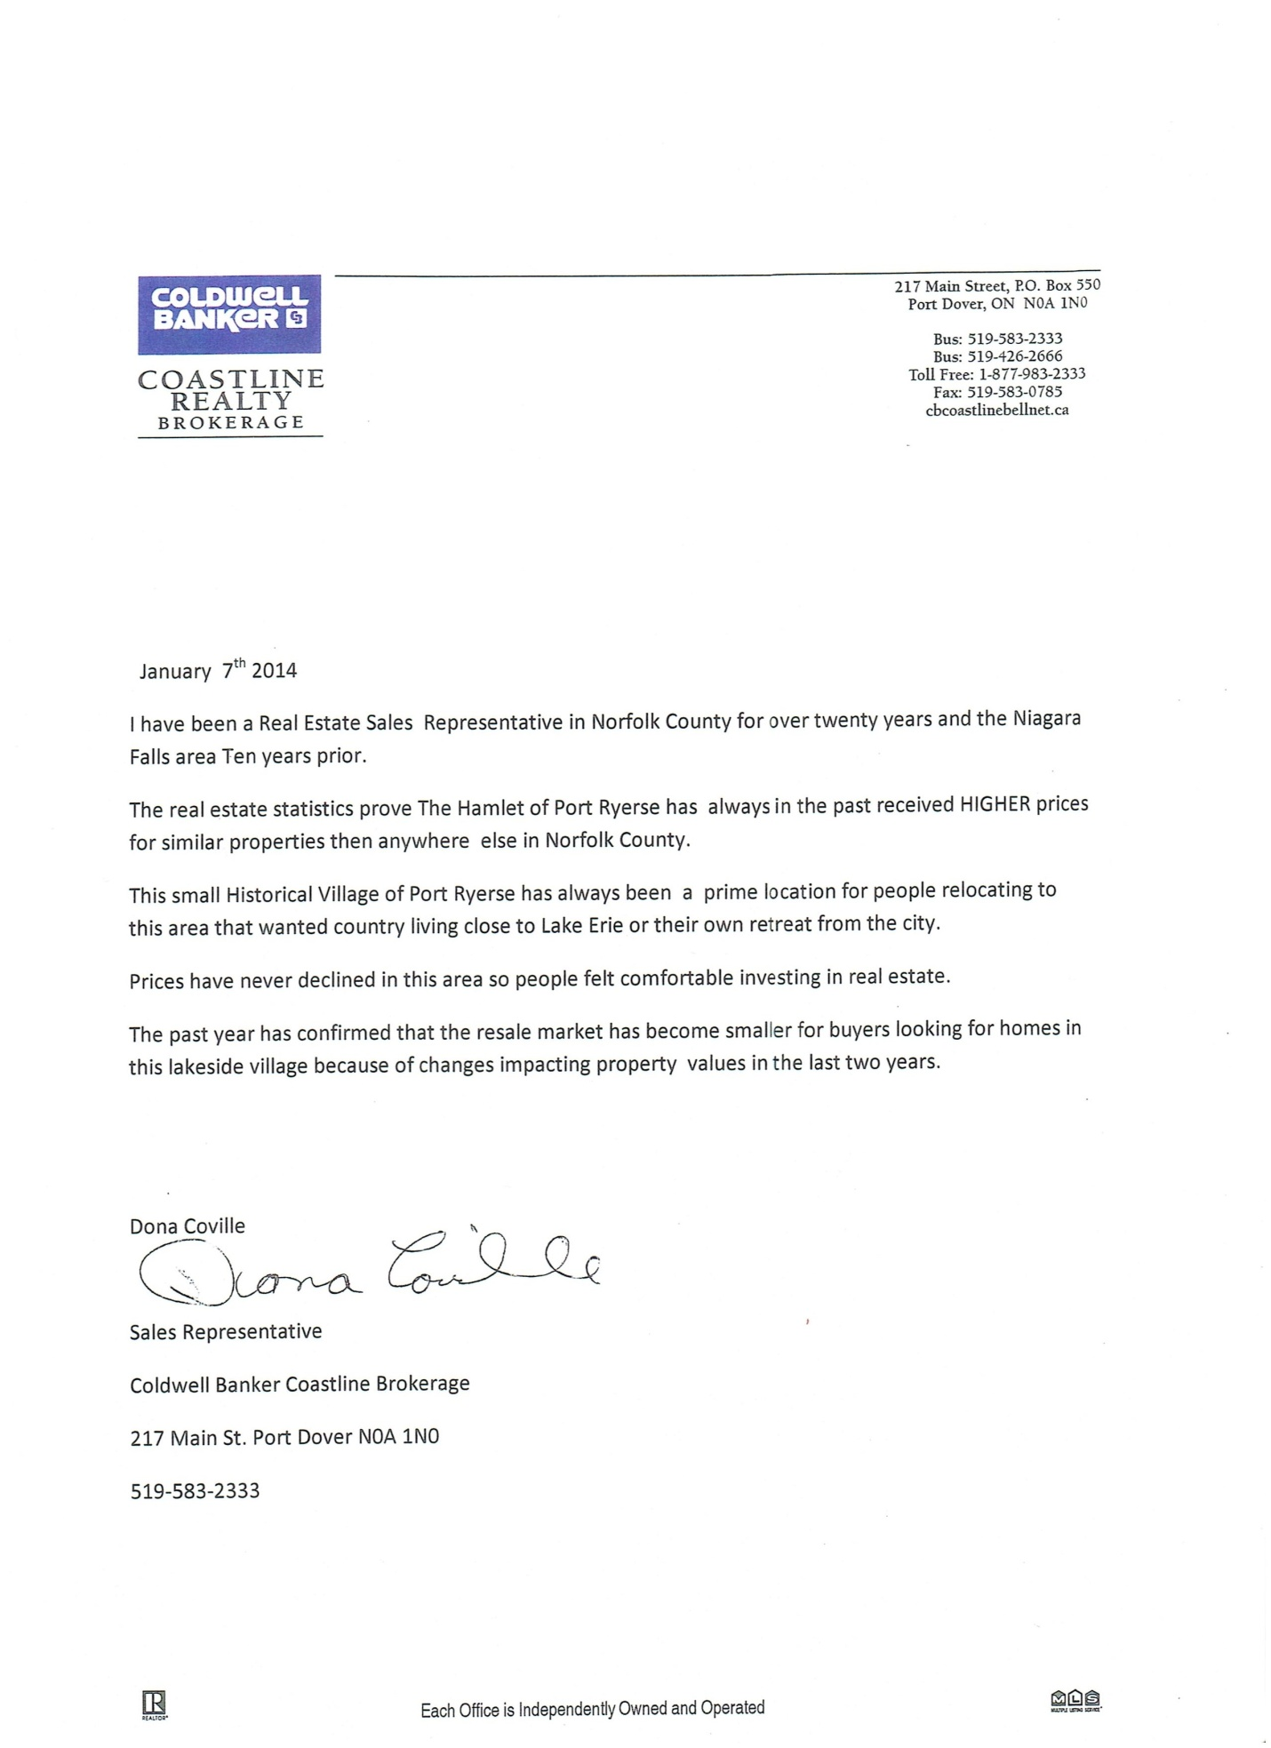
Sincerely

Shana Greatrix
Box 49, R.R. 3
(28 Rolph St., Port Ryerse)
Simcoe , ON
N3Y 4K2

