28 Rolph St., Port Ryerse
R.R. 3 Simcoe N3Y 4K2
March 3, 2013

To whom it may concern:
I live in the hamlet of Port Ryerse where the proposal of 4 wind turbines (with more to be added later) came forward two years ago from UDI Renewables who had made a deal with 4 farmers 750 metres from my home and within a closer range to the homes of most of the people who live in the hamlet and the adjoining one named Avalon Park. We all were in shock since we never had any say in the matter of such devastating proportions to the beautiful area we live in. In brief, this is one of the worst possible cases of why the green wind experiment in Ontario is totally dysfunctional. Everything is bad about it from the undemocratic process, the potential environmental and geological threats, the health concerns which are now proven with such short setbacks, the ruination of a heritage village celebrating its survival from the War of 1812 with rich built heritage surrounded by cultural heritage landscapes, scenic roadways, breathtaking vistas from the inner bay of Lake Erie of the cliffs coming out of Port Dover down to a World Biosphere Reserve at Long Point directly across from our village and a thriving tourist business for these very reasons. One can only question what the gain is for destroying all this and such a huge price to pay to benefit 4 farmers and one greedy opportunistic developer now having sold out to a larger corporation named Boralex with even less interest in the people and the land. It is purely only for one reason: the Feed-in-Tariff program associated with wind available at this time through our overly zealous Liberal provincial government and nothing about any sustainable wind energy here.
When I look at the principles of sustainability set by the United Nations in 1992 in Rio, I see an industry that has lost the very ideals it still claims and hides behind calling itself green and sustainable. I questioned the representative of Boralex at the final public meeting about how this project met with these principles, and of the 10 I read out, she could not say with any certainty that any of these were being met with their proposal. In the end the only one reason that the company is interested in being here is for the 20 year period of the FIT program while it is in effect. After that there would not be sufficient money to sustain their interest to prove its sustainability.

Here are the 10 principles I mentioned:
Principle 1
Human beings are at the centre of concerns for sustainable development. They are entitled to a healthy and productive life in harmony with nature…. NOT BEING MET- We are concerned that proper studies have not been accepted to guarantee our health and the safety for our migratory birds, endangered species and those at risk such as bald eagles with the noise and very bad judgment of placement next to a World Biosphere Reserve.

Principle 3
The right to development must be fulfilled so as to equitably meet developmental and environmental needs of present and future generations. NOT BEING MET- This project is purely for the 20 year period to satisfy the benefits of an income for 4 farmers and the developer while the FIT program is available.
Principle 4
In order to achieve sustainable development, environmental protection shall constitute an integral part of the development process and cannot be considered in isolation from it. NOT BEING MET- This project will destroy good farmland and the habitat of birds, bats, and the wildlife protected by the Long Point Conservation Authority right across from the area and is a pathway for migratory birds. The drilling into a cliff of glacial till which is constantly eroding will imperil the lives and properties of those who live along the cliff. (see attached images)
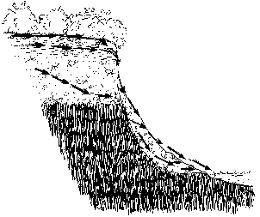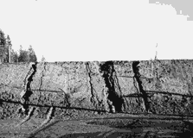
Principle 5
All States and all people shall cooperate in the essential task of eradicating poverty as an indispensable requirement for sustainable development, in order to decrease the disparities in standards of living and better meet the needs of the majority of the people of the world…..NOT BEING MET- The cost of electricity will be putting the most vulnerable at risk in the province.
Principle 8
To achieve sustainable development and a higher quality of life for all people, States should reduce and eliminate unsustainable patterns of production and consumption and promote appropriate demographic policies. NOT BEING MET- This is not improving anyone’s way of life except the monetary benefit of 4 farmers and one big wind company. This is an UNSUSTAINABLE Pattern of Production.

Principle 9
States should cooperate to strengthen endogenous capacity-building for sustainable development by improving scientific understanding through exchanges of scientific and technological knowledge, and by enhancing the development, adaptation, diffusion and transfer of technologies, including new and innovative technologies. – NOT BEING MET- Other more appropriate technologies with fewer impacts for our community are not being considered.
Principle 10
Environmental issues are best handled with participation of all concerned citizens, at the relevant level. At the national level, each individual shall have appropriate access to information concerning the environment that is held by public authorities, including information on hazardous materials and activities, in their communities, and the opportunity to participate in decision-making processes. States shall facilitate and encourage public awareness and participation by making information widely available. Effective access to judicial and administrative proceedings, including redress and remedy, shall be provided. NOT BEING MET-The undemocratic process has excluded the involvement of the people with the greatest vested interest and the groups such as Bird Studies Canada, the local Conservation Authority and the local municipal government.
Principle 11
States shall enact effective environmental legislation. Environmental standards, management objectives and priorities should reflect the environmental and development context to which they apply. Standards applied by some countries may be inappropriate and of unwarranted economic and social cost to other countries, in particular developing countries…..NOT BEING MET- Standards of zoning by-laws to protect areas have been ignored. Zoning of “Agriculture” has come to mean an “Industrial Park”.
Principle 15
In order to protect the environment, the precautionary approach shall be widely applied by States according to their capabilities. Where there are threats of serious or irreversible damage, lack of full scientific certainty shall not be used as a reason for postponing cost-effective measures to prevent environmental degradation…NOT BEING MET- There is no full scientific certainty that these gigantic turbines will not cause harm through the vibration and noise created re the integrity of the cliff and any means to prevent a disaster.
Principle 22
Indigenous people and their communities and other local communities have a vital role in environmental management and development because of their knowledge and traditional practices. States should recognize and duly support their identity, culture and interests and enable their effective participation in the achievement of sustainable development. NOT BEING MET- The entire surrounding community has been ignored and must come to its own defense through legal recourse to protect their own properties and their health.

Last but not least, I examined the Heritage Impact Assessment Report along with many others including the Norfolk Heritage Committee which I am part of and top architectural experts who believe in Conservancy as well as heritage professors and planners. We all see the disparity in the judgment of the conclusions where those doing the report profess that there will not be any impacts on the heritage of the area. After identifying all of the attributes and features of the area and then suddenly concluding there will be no impact may be the work of an engineer, but not the work of a qualified heritage planner or engineering company with an interest in heritage and conservancy. In my Appendix I outline the flaws of the report which I communicated to the company based on their own guide to make a heritage impact assessment report. They did not consult with anyone except a County clerk to provide data on file. They totally left out how the turbines would visually pollute the scenic roadways, the backyards of everyone within 2 km. and the important landscape view from the water where boaters and tourists enjoy the rustic quaint villages perched on the cliff (see attached view with the simulation of the turbines which was not included in the report). Also see the attached letter from our Norfolk Heritage Committee to the Ministry of Tourism, Culture and Sport in Appendix.
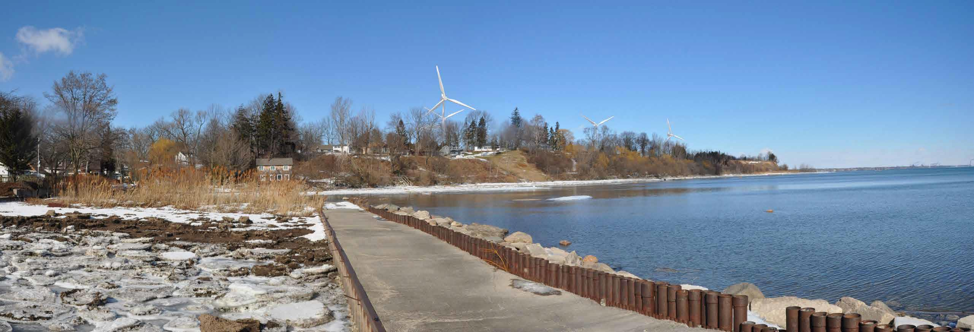
Conclusion:
It is unfortunate that everyone has been put in the way of what has been released from Pandora’s green energy box with the Liberal twist. The residents of Port Ryerse feel that no one is listening to their concerns for their property values, their health concerns, their heritage including the cultural heritage landscape with scenic roadscapes and waterscapes, the concern for the landscape of the cliff and the safety of the people precariously perched atop it facing problems of erosion, the habitat for wildlife and the visual impact in general. More respect must be shown to those who have built the heritage of over 200 years and the land that has always been here for the wildlife and the many different people to live on.
The process the Liberals created to blindly go full speed ahead with their wind energy plan removed democratic and civil rights for anyone outside of the dealmakers. The residents around Port Ryerse and Avalon Park have seen their time wasted playing the game through this process without their concerns being addressed even with the impact assessment reports. Hopefully we can pull this bad crop out at the roots through this wasteful process that never should have started at all if proper democratic and protective rights had remained in place.
Sincerely,
Shana Greatrix, resident of Port Ryerse
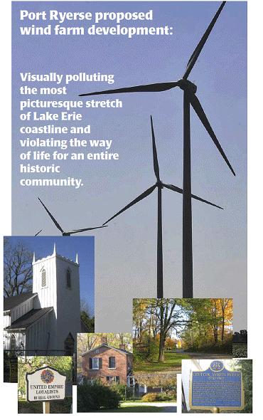
Appendix A)
Norfolk Heritage Committee (Council Advisory Committee for Norfolk County)
Comments on proposed Industrial Wind Turbine installation at Port Ryerse
The Norfolk Heritage Committee (NHC) is the principal organization in this county for comment and/or protective action on heritage preservation. Guidelines for this committee’s activities are set out by the Ontario Heritage Act and the Official Plan of the Corporation of the Municipality of Norfolk County.
According to direction from these two levels of government, the currently appointed members are required to and have looked at the probable impact on the perception of heritage character at Port Ryerse, should some IWTs be installed nearby.
At the Ontario level, The Provincial Planning Act “recognizes that heritage protection and conservation is a key component of good land use planning…[and] identifies the conservation of built heritage, [and] cultural heritage landscapes...as provincial priorities. The Planning Act requires that decisions affecting planning matters…shall be consistent with the Provincial Policy Statement.”
At the county level, in its advisory capacity, the NHC looks for guidance within the Official Plan and to policies derived from that document. The Norfolk Development Policies specifies that “new development…shall have regard for heritage resources” and “Council shall encourage the conservation and protection of cultural heritage resources or the mitigation of adverse effects on cultural heritage resources…”
The county recently secured the services of Unterman McPhail to write the Cultural Landscape and Built Heritage Study of Norfolk County. Port Ryerse was given special mention as an asset, important to the development of lakeshore policy.
The NHC identifies Port Ryerse as a whole, with its historic barns, residences, church and 1812 cemetery, as a heritage resource. To this date, the compact village has been almost unsullied. For those reasons, it will be officially designated by the County as a Historic Village in 2013, a rare honorarium.
The installation of an array of towering wind turbines will bring a new overbearing visual presence to Port Ryerse. At the provincial level, this would not be protective of visual heritage values, nor would it be a “component of good land use planning”---a violation of the intent of Provincial statutes. At the municipal level, this would be in disregard “of cultural heritage resources”, and moreover the “mitigating of adverse effects” have never been suggested in regard to the visual impact, and are indeed not at all possible.
The Provincial Green Energy Act has brought pressures to bear that contradict the intention of “good land use planning” in this county. Under pressures from this act, Norfolk County has developed policies for “wind farms”. They shall be “located on large parcels of agricultural land”…with only limited existing residential development nearby, and separated to reduce visual intrusion. Policy is that “a visual impact study shall be undertaken to determine the impact and mitigation measures required for wind turbines on the landscape as viewed from Lake Erie, municipal roads or other public access land.” Sadly, there are no mitigation measures yet developed to render a wind farm invisible if sited close enough to be seen from a cultural heritage area such as a historic village.
The Norfolk Heritage Committee does not pass judgment in isolation from related factors. We recognize the conflicts created by the Green Energy Act, and we are also aware of potential dangerous weaknesses in the substrata where these heavy vibrating machines are slated to be installed. We would be much more hesitant to recommend against a truly safe and green development in energy creation. However, no information in support of the necessity of wind turbines in delivering efficiencies to the electricity grid---in fact practically nothing at all to recommend this development---has been heard in our committee room, although we have listened. We confine ourselves to heritage conservation, and hearing nothing to the contrary to embarrass our recommendation, we advise “no” to visually degrading intrusions within sight of any major heritage resource and in particular, historic Port Ryerse.
Ross Bateman, Chairman, Norfolk Heritage Committee

Appendix B) What is lacking in the Environmental Assessment report re Port Ryerse Windfarm(?) proposal…from the Green Energy Act……what they missed:

2.2: Investigation
This section provides guidance on how to conduct an investigation, including historical research and visual inspection.
There are five steps involved in undertaking a site investigation:
1. Identify the study area.
2. Consult with municipal staff, Aboriginal communities, heritage organizations and the public to learn more about the cultural heritage of the community.
3. Apply preliminary criteria to screen for known and potential heritage resources and create an inventory.
4. Analyze inventoried resources through a site visit.
5. Investigate inventoried resources through further historical and archival research, historical maps, municipal records and interviews.
1) The Study Area:
For the purposes of the heritage assessment, considering a larger study area is a recommended best practice. The study area may be defined as the geographic area that may be altered or impacted because of the proposed project.
The nature of the existing terrain, land elevations, vegetation, waterways, roadways, rail corridors, protected properties and known heritage resources, along with any other relevant environmental factors should be considered when defining the study area. The study area and project location should be clearly depicted on a map that is included in the final report.
2) Community Input:
Under O. Reg. 359/09, the applicant is required to consult with the public, municipalities, and Aboriginal communities regarding the proposed project. The person conducting the heritage assessment should make their best efforts to ensure that any heritage concerns brought forward during early public meetings and through any engagement with Aboriginal communities are incorporated into the heritage assessment. Proactive engagement with community members can save the proponent from having to make costly alterations to project layouts if a heritage concern is brought forward at the final public meeting, or after the application is submitted to MOE.
Heritage and archaeological sites are of critical importance to First Nations, Métis and Inuit communities. Aboriginal communities may have information about heritage sites that are of special importance to their community and should be involved in the assessment process. Information about cultural heritage resources should be requested during the formal Aboriginal engagement process. Please note that traditional knowledge may be considered sensitive. For further information on engaging Aboriginal communities please see MTCS’ Draft Technical Bulletin: Engaging Aboriginal Communities in Archaeology. Although this document refers specifically to archaeology, it provides general background material on effective approaches to engaging with Aboriginal communities overall.
Municipal staff will be a helpful resource throughout the identification and evaluation processes. If the municipality has a municipal heritage planner and/or a Municipal Heritage Committee (MHC), they should be contacted when conducting the heritage assessment. The local community may also have a historical society, heritage museum, Architectural Conservancy of Ontario (ACO) local chapter, or other local heritage interest groups that may be consulted.
Information can also be gathered from local heritage groups, librarians, museum curators and historians, as well as published local histories. These sources will help to establish the community context and identify historical themes that can be used in screening for potential heritage resources. Community members may also direct the qualified person to important heritage resources that are not easily identifiable through archival sources or site visits.
The objective of consulting with interested individuals and groups is to identify all potential and known cultural heritage resources that may be affected by the proposed development. Engaging interested parties early in the heritage assessment process can help to ensure that review is not delayed. Efforts to conduct interviews and the information gathered in the interviews should be documented in the heritage assessment report…….
4) Site Visit:
The purpose of the site visit or windshield survey is to record and analyze the physical characteristics of the project location and to develop knowledge of the landscape and context of the heritage resources.
The qualified person should make a visual and written record of each building, structure or landscape in sufficient detail to clearly illustrate significant features. Descriptions should be clear and concise and touch on all significant features, and photographs should accompany a brief written profile of each heritage resource. Photographs should be cross-referenced to vantage points marked on plans and should include compass point references for each view.
Photographs of buildings and structures should provide information on massing, materials, architectural features such as wall design, roof shape, windows, property layout, principle views and the setting of the building and relationship between the building or structure and the surrounding landscape. For example, photographs should show:
• principle elevation and at least one side elevation

perspective views of rear, front and side, general view from a distance sufficient to show setting, landscape and adjacent buildings, if relevant, detailed views of important components such as entrances, windows, structural components, and/or technological features such as machinery and equipment

For landscapes, multiple views and perspectives should be recorded and photographed. Topography, elevations, and any significant man-made or natural features which may provide clues to the historical development and character of the area should be identified. For example, photographs should:
• demonstrate overall contextual views and show the relationship and placement of site elements

show general views of features that characterize the landscape

show perspective views of contributing elements, buildings and structures

⇐ Photographs should be taken from the nearest publicly accessible viewpoint. For private property, permission must be sought to access the property for the purposes of site analysis and photographic documentation…..

Interest
For any property or landscape that is determined to be of cultural heritage value or interest, the report should articulate how the resource meets Regulation 9/06 in a Statement of Cultural Heritage Value or Interest. The Statement should convey why the property is important, explaining those cultural meanings, associations and connections the property holds.
The Statement should clearly articulate why or what makes the resource significant and anticipate potential changes or alterations resulting from the proposed project that may have an impact on the cultural heritage value of the property. The statement should identify the resource’s heritage attributes. Heritage attributes can be defined as the physical features, materials, forms, locations or spatial configurations that contribute to, support, or embody each value and provide an explanation as to why this is significant.
10. The heritage assessment should clearly describe the relationship between heritage value of the site or property and the identified heritage attributes.
The Statement should provide sufficient information to explain the significance of the resource, and should be approximately two to three paragraphs. The Statement should include built, structural and landscape features, and clearly identify the resource’s physical attributes and associations, as well as the cultural meaning that the resource holds to the community. For each identified value, the Statement should specify the key heritage attributes that are associated with these meanings.
If, after the evaluation process, a resource is found not to have cultural heritage value or interest, the person conducting the heritage assessment should prepare a summary statement that explains the conclusions and recommendations of the heritage assessment report. There should be a clear rationale made in the report specifying why no further assessment or evaluation is required. …

Destruction
• Destruction or removal of any, or part of any of the identified heritage attributes.
Alteration
• Alteration of a building, structure or landscape in a manner that is not sympathetic, or is incompatible with the historic fabric and appearance.

Vibration damages to a structure or building during construction or because of changes to adjacent land use.

Introduction of elements that visually or physically diminish the heritage value of a landscape, structure or building.

Shadows
• Shadows that alter the appearance of a heritage attribute or change the visibility of a natural feature.
Isolation
• Reduced accessibility to landmark, monument or public site.

Change in relationship or isolation of a heritage attribute or resource from its surrounding environment or context.

Obstruction

• Obstruction of significant views from or of a built heritage resource or a cultural heritage landscape.

Obstruction through the rerouting of traffic, alteration of roadways or gateways near a landmark that limit access to a resource or property.

Change in Use
• Change of use or neglect of a heritage resource which causes deterioration of heritage attributes.
Land disturbances
• Widening of existing rural roads, introduction of new roads, and/or removal of plantings, etc.

Land disturbance, such as a change in grade that alters historical patterns of topography or drainage.

If a proposed project will not affect the attributes that embody the cultural heritage value of a resource, it is generally understood that a finding of no impact is appropriate; however the report should demonstrate how this conclusion was reached for each identified heritage value….
11. MITIGATION- The heritage assessment report must provide recommendations including mitigation options and conservation strategies to avoid or reduce impacts. The heritage assessment report should include a rationale for why the proposed mitigation is the best possible solution and why other alternatives are not viable (e.g., perhaps other environmental constraints limit potential mitigation options).
Mitigation may include, but is not limited to the following:
• impacts are avoided and project components and construction activities are distanced from heritage resources

mitigation through design, or alternative development approaches

sympathetic alteration that respects the heritage attributes of the cultural heritage resource

alterations or new construction that are reversible

physical and visual compatibility with the existing cultural heritage resource

layout or component design alternatives that minimize visual intrusions

separation distances or compatible visual barriers specified to avoid or reduce visual impact to the identified heritage resource

introduction of sympathetic plantings, materials and features

where no in-situ conservation option is feasible, moving and/or relocating a built heritage resource

interpretation and commemoration (where relevant)

Where the effect of proposed work is likely to negatively impact the cultural heritage value of a resource, each negative impact should be identified with a statement as to why they could not be avoided.
If heritage attributes are to be removed or the heritage resource is to be demolished, the heritage assessment report must include the rationale for removal and the process for documentation of pre-existing conditions (e.g., photographs, measured drawings and salvage materials).
If long-term protection of a heritage resource is proposed, the heritage assessment report might recommend that a heritage conservation plan be developed. The conservation plan, prepared separately as a condition of approval, should be a stand-alone document with a defined purpose, tailored to the heritage resource being conserved. The objective of a conservation plan is to set out a strategy for managing and conserving the heritage attributes of a resource over the long term. It should provide the owners and managers of the heritage resource with useful tools and advice for ongoing management of the resource. The heritage assessment report should include the rationale for recommending a conservation plan over other mitigation strategies.

