Municipal Law Seminar
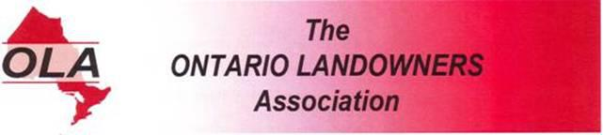
The Niagara Landowners Association is hosting Niagara’s first OLA Municipal Law Seminar.
September 21, 2013
At the Ramada Beacon Harbourside Hotel in Jordan Ontario.
Doors open at 11am for chat
Seminar 1pm to 5pm

Come out and learn what the law really is and not what you are told it is. The “Ontario Municipal Act” is very clear. Your Rights on your Private Property have already been protected.
Panelists will include;
Elizabeth Marshall, Director of Research Ontario Landowners Association
Director Canadian Justice Review Board
Associate Research Fellow - Meighen Institute for Public Affairs
Cynthia Moyer, President of the Huron Perth Landowners Association and CAO of the Legal Services Co-operative of Ontario
Tom Black, President of the Ontario Landowners Association.
Directions; http://www.ramadabeacon.com/location.htm 2793 Beach Boulevard, Jordan Ontario, Exit # 55 from QEW. For information contact Bob Mackie at 905-563-5852, Email, niagaralandowners@gmail.com Cost; $10.oo at the Door

